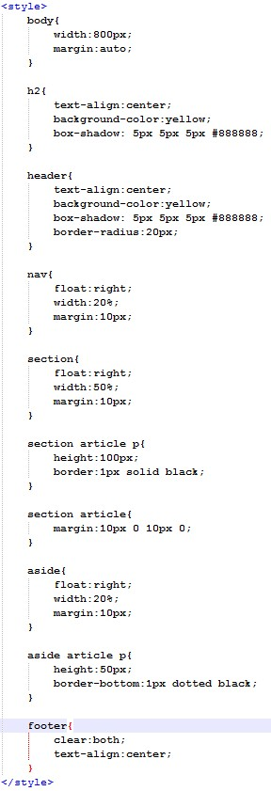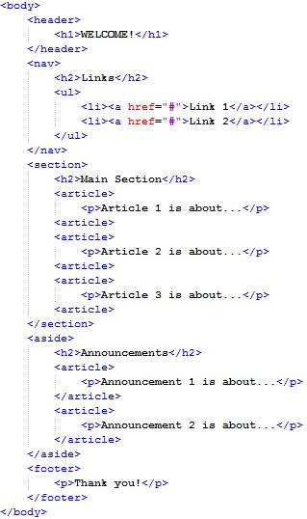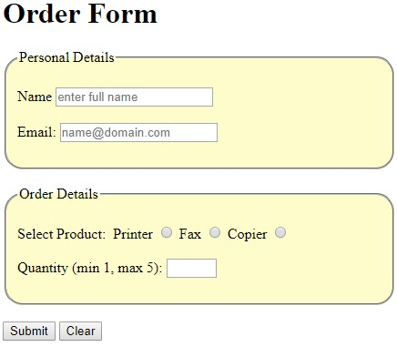

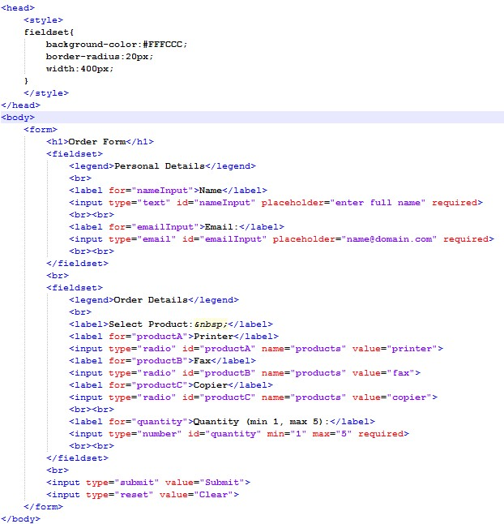  
  
  
  
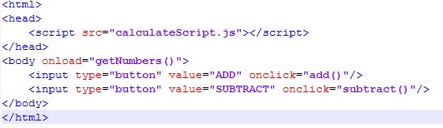  
  
calculateScript.js

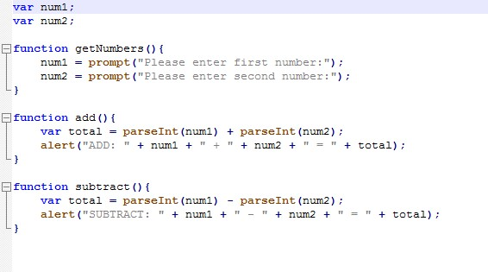

CSS Notes:

box-shadow: 1px(x-) 1px(y-) 1px(blur) #FFFCCC(color)

border-radius: 20px; (Or 20px 20px 20px 20px)

border-collapse: collapse; ( border="1" )

border-spacing: 10px; ( Only works when border-collapse: separate; )

overflow: scroll; ( or hidden)

margin: auto;

text-align: center; (Not centre)

text-decoration: none;

text-shadow: 1px(x-) 1px(y-) 1px(blur) #FFFCCC(color)

JavaScript notes:  
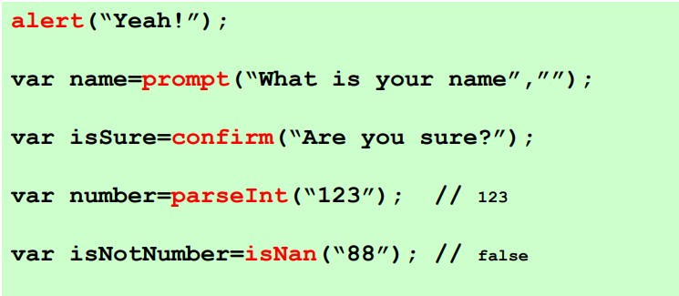 isNan (is not a number) 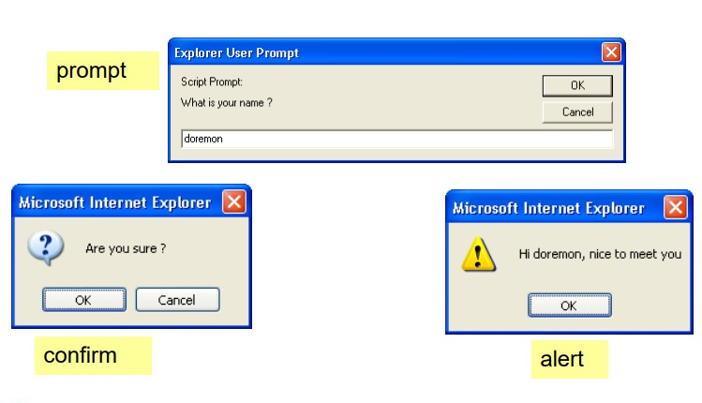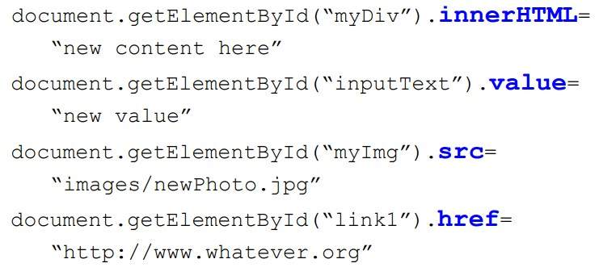  
  
  
  
  
  
  
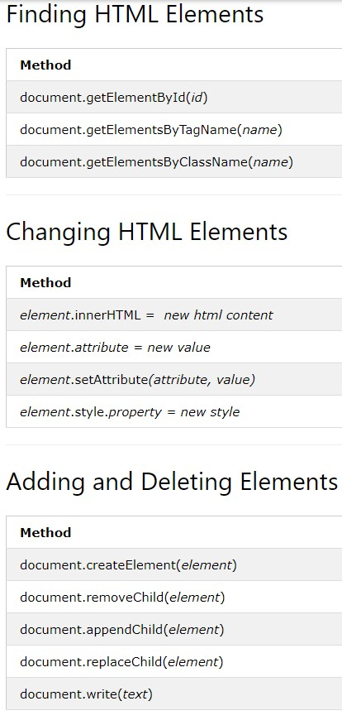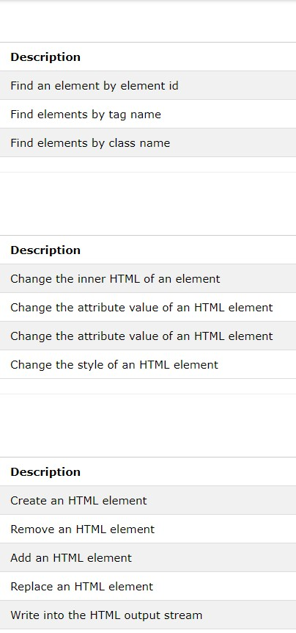  
  
  
document.getElemetsByTagName()  
  
document.getElemetsByClassName() are in arrays  
  
